Building a 2D simulation model for turning process using the Abaqus application – Stage one

Exercise stages:
Stage one
- build a 2D geometrical model of the workpiece and the tool,
- assign material properties to the workpiece and the tool,

make an assembly,

define the analysis steps.
Stage two
- create and verify the turning simulation model,
- make a turning process simulation for specific cutting parameters,
- analyse the results.

Abaqus Student Edition 2019 programming environment

Free download
https://academy.3ds.com/en/software/abaqus-student-edition
The application is intended for students and other education-related users. The difference between the student and commercial edition is the limitation to 1000 nodes.
To start the software click Menu Start\All programs\Dessault Systemes SIMULIA Abaqus Student Edition 2019 and select Abaqus CAE.

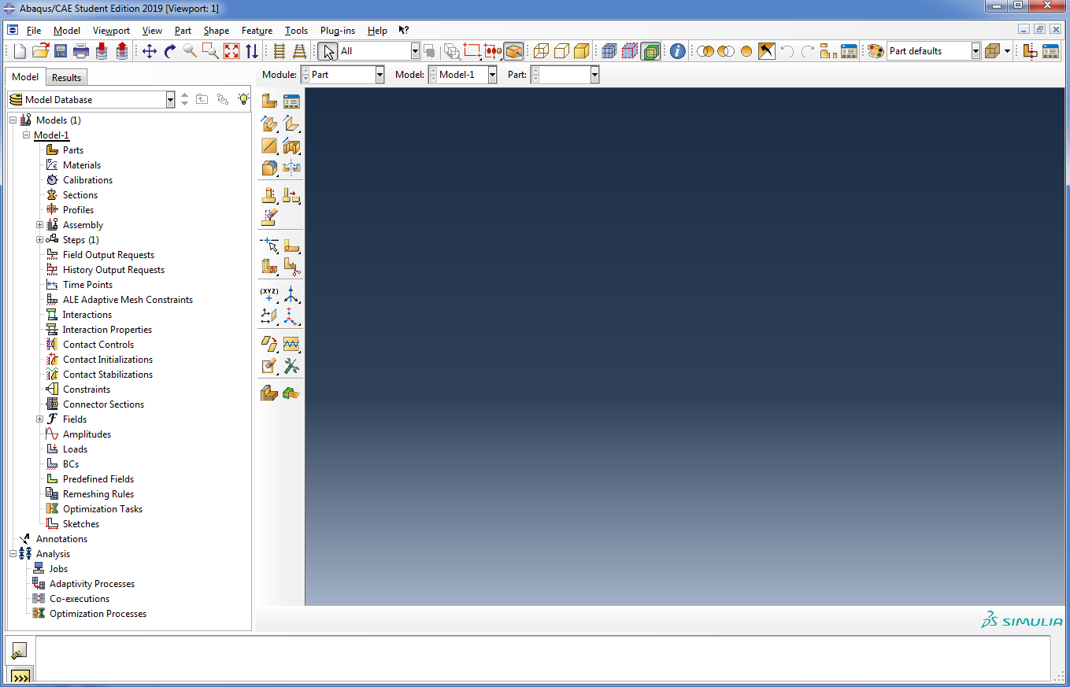
Fig. 1.1 Abaqus software window
. 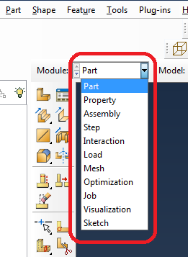
Fig. 1.2 List of available modules in Abaqus

Design a geometrical model of the workpiece and the tool
The actual 3D model of the cutting process has been simplified to a 2D simulation model.

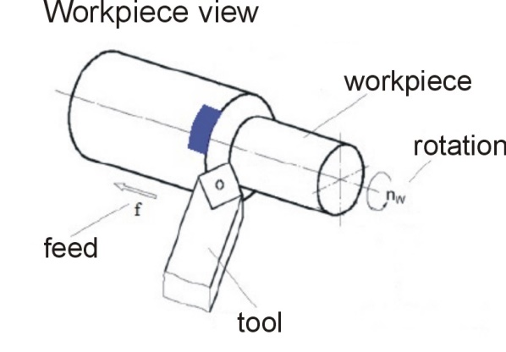 | 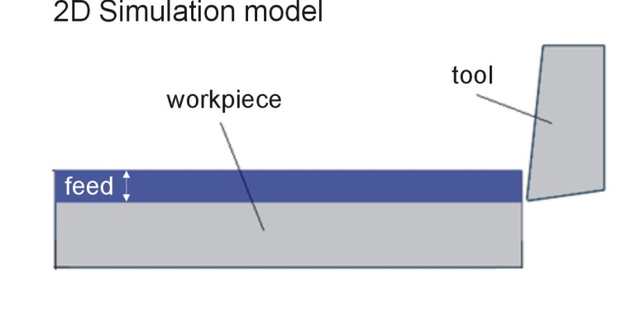
Fig. 1.3 The actual 3D model of the cutting process | Fig. 1.4 2D simulation model

Design the workpiece geometry

Start the “Part” module, then “Create Part.” Complete the remaining fields according to the Fig. below.
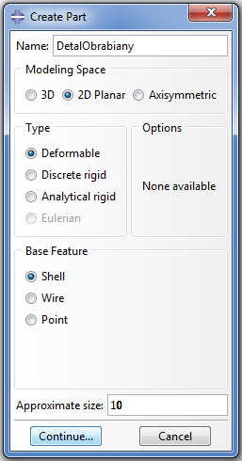
Fig. 1.5 Selected parameters in the “Create Part” dialog box

Draw the workpiece shape in the sketchpad that is displayed: select “Create Lines Rectangle (4 lines)” and create any rectangle. To dimension, select the “Add Dimension” icon. When you have determined the geometrical dimensions (0.5 x 2.4 mm) – Fig. 1.6, press “Done” in the bottom bar to leave the sketchpad. If there is no such button, right-click in the working area and select “Cancel Procedure.”

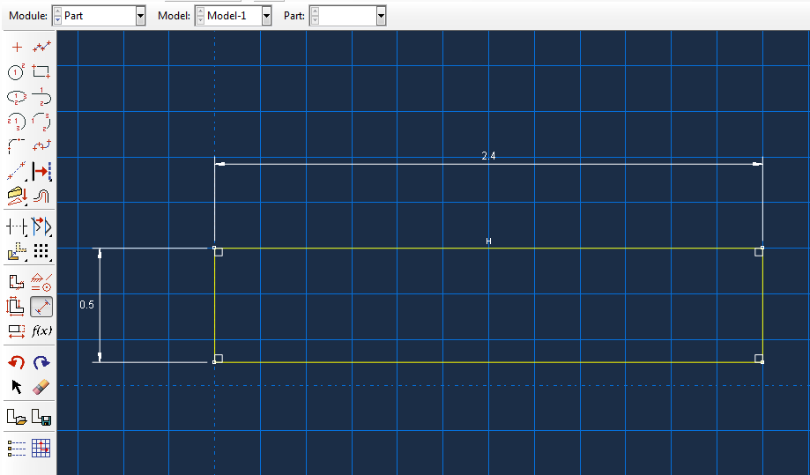
Fig. 1.6 The geometrical dimensions of the workpiece

Design the cutting blade geometry

In the next step, draw the cutting blade geometry using the „Create Lines: connected” option to create the cutting tool outline as shown in Fig. 1.7.

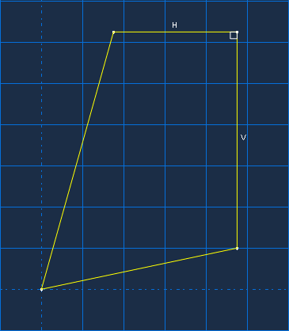
Fig. 1.7 Cutting tool outline

In order to apply the chosen dimensions, create the construction lines using the “Create Construction: Oblique Line Thru 2 points” option. The location of construction lines is presented in Fig. 1.8. Note that the beginning of both auxiliary lines is on the tool edge (the necessary condition to apply the correct dimensions).
Use the “Add Dimension” tool in the “ToolBox” area to determine width by selecting the vertical, right-hand line of the cutting tool and the vertical construction line and enter the value of 0.4 mm, and then determine the height by selecting the top cutting tool geometry line and the horizontal auxiliary line and enter 0.8 mm. To add the clearance angle, click the relief face line and select the horizontal auxiliary line and enter 8. Identically, enter the rake angle by selecting the rake face line and entering 6. To determine the cutting tool radius, from the “ToolBox” area select “Create Fillet: Between 2 Curves.” Click the tool icon in the status bar and determine the “Fillet radius” by typing 0.02 mm. Press “Enter” to confirm and then select the cutting tool’s relief face and rake face.
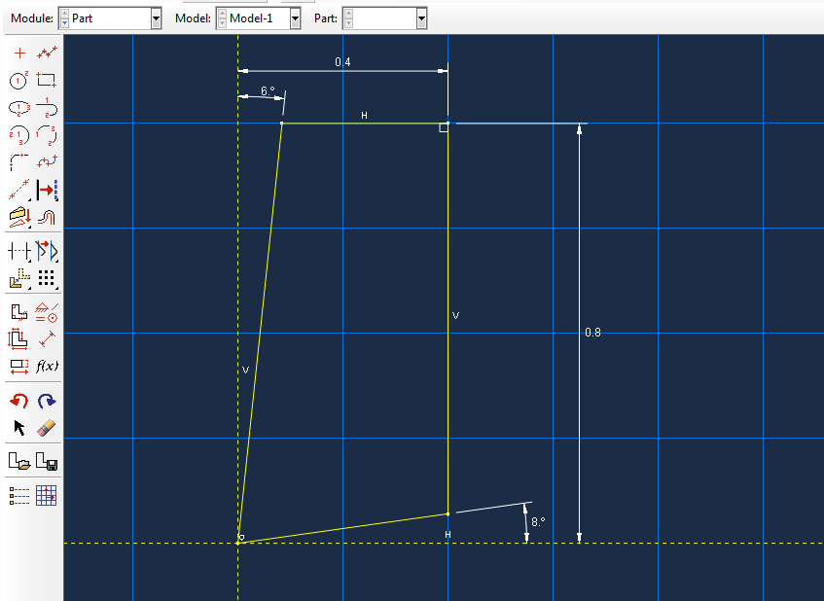
Fig. 1.8 Applying geometrical dimensions to the tool

Determine the materials properties of the model
- Ti6Al4V titanium alloy for the workpiece,
- Sintered carbide for the cutting tool.
The Abaqus does not have clearly defined units during the entering of the material data, so the necessary condition is to use one, consistent system for all parameters. The recommended units are presented in Table 1 (based on the Abaqus help).
Table 1. Recommended units for the Abaqus software [15]
Value | SI | Abaqus
Length | m | mm
Force | N | N
Mass | kg | tona (10³kg)
Time | s | s
Stress | Pa (N/m²) | MPa (N/mm²)
Energy | J | mJ (10⁻³J)
Density | kg/m³ | ton/mm³

Table 2. Parameters calculated for Ti6Al4V titanium alloy
Value | Converted unit
Density - ρ | 4.43e-009 t/mm³
Young’s Modulus - E | 110000 MPa
Poisonn ratio - v | 0.33
Specific Heat Capacity - C_{p} | 560 000000 mJ/t·K
Thermal Conductivity - λ | 6.6 mJ/m·K
Inelastic Heat Fraction - β | 0.9
Expansion coefficient – α | 8.9E-006 1/K

Table 3. Ti6Al4V parameters - model Johnson-Cook
A | B | C | n | m | T_{melt} | T₀
1098 MPa | 1092 MPa | 0.014 | 0.93 | 1.1 | 1903.15  [K] | 298.15  [K]

Table 4. Ti6Al4V parameters - model Johnson-Cook damage
$$D_{1}$$ | $$D_{2}$$ | $$D_{3}$$ | $$D_{4}$$ | $$D_{5}$$ | $$ε_{0}$$
-0.09 | 0.25 | -0.5 | 0.014 | 3.87 | 1

Table 5. Parameters calculated for Sintered carbide
Value | Converted unit
Density - ρ | 1.45e-009 t/ mm³
Young’s Modulus - E | 650 MPa
Poisson ratio - v | 0.25
Specific Heat Capacity - C_{p} | 15000000mJ/t·K
Thermal Conductivity - λ | 59 mJ/m*K
Expansion coefficient – α | 4.9e-006 /K

To enter the material properties, use the “Property” option and then select “Create Material” . In the new “Edit Material” window, in the “Name” field, enter the workpiece material, Ti-6Al-4V in this case. Enter the material properties using the drop-down list under the “Material Behaviors.” The parameters of Ti6Al4V from tables 2, 3 and 4 have been added as shown in Table 6.
Table 6. The material properties of Ti6Al4V
Thermal Conductivity λ = 6.6 mJ/m*K  „Thermal” → „Conductivity” | 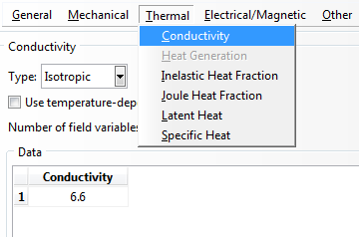
„Johnson-Cook Damage”  „Mechanical” → „Damage for Ductile Metals” → „Johnson-Cook Damage”.  $D_{1}$=-0.09 $D_{2}$=0.25 $D_{3}$=-0.5 $D_{4}$=0.014 $D_{5}$=3.87 Reference Strain Rate = 1 | 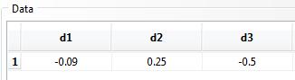  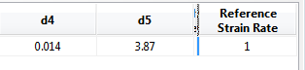
Density ρ = 4.43E-09 t/mm³  „General” → „Density” → „Mass Density” → 4.43E-09 | 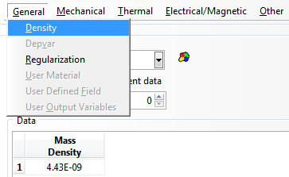
Young’s Modulus  E= 110000 MPa  Poisson’s ratio v =0.33  „Mechanical” → „Elasticity”  → „Elastic”. | 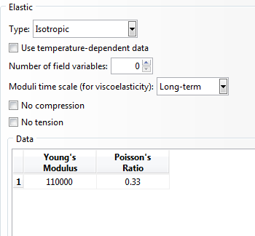
Expansion Coeff α =8.9E-06 1/K  „Mechanical” → „Expansion” → „Expansion Coeff”. | 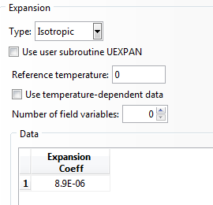
Inelastic Heat Fraction = 0.9 %  „Thermal” → „Inelastic Heat Fraction” → „Fraction” → 0.9. | 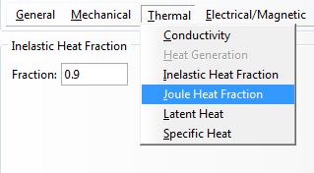
Model Johnson-Cook  „Mechanical” → „Plasticity”  → „Plastic” → „Hardening” → „Johanson-Cook”.  Enter:  A=1098 B=1092 n= 0.93 m=1.1  „Melding Temp” = 1903.15  „Transition Temp” = 298.15  „Suboption” → „Rate Dependent” → „Hardening” → „Johanson-Cook  Enter  C=0.014  „Epsilon dot zero” = 0.001 | 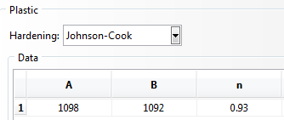  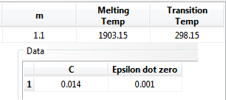
Specific Heat  C_{p} = 560000000 mJ/t·K  „Thermal” → „Specific Heat”  → 560000000. | 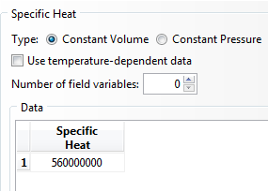

Finish the adding of the Ti6Al4V properties by pressing OK in the bottom part of the window. Next, select “Create Material” from the “ToolBox”, give the name in the “Name” field, and enter the sintered carbide parameters from Table 5.

Design material sections
For a correct simulation, it is necessary to create appropriate material sections for both the workpiece and the cutting tool. To create the material section, open “Property”, and then select “Create Section” marked with the symbol . Enter the section name in the new window “Name”, “SekcjaWeglik” in this case. Check the remaining sections according to Fig. 1.9. Press “Continue” to display the “Edit Section” window in which you should select the cutting tool material and press “OK” to approve as shown in Fig. 1.10.

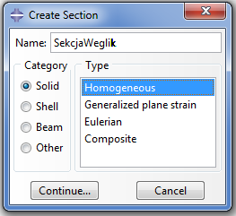  Fig. 1.9 Select “Create Section” | 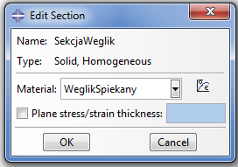  Fig. 1.10 Definition of material
Use the same procedure to create a section for the workpiece: enter the name and select the material. Next, assign sections to appropriate elements. Double-click “Ostrze” in the “Part” category, change to the “Property” module and use the tool. The “Select the regions to be assigned a section”, message will be displayed in the bottom part of the screen, so select the visible part and press “Done” to approve. The “Edit Section Assignment” dialog box will be displayed in which in “Section” you need to select the appropriate section for the previously selected element. Finish the operation by pressing “OK.” Assign the appropriate section for the workpiece in an analogous manner.
If you have done all operations correctly, after going to the “Assigned” module each element should be in the green colour.

Make an assembly
To make the assembly, use the “Assemble” module: in the “ToolBox” area click the “Instance Part” tool to display the “Create Instance” dialog box. Select „DetalObrabiany” and click “Apply”, then perform an analogous operation for the “Ostrze” part. If you have done everything right, the view will be as shown in Fig. 1.11.

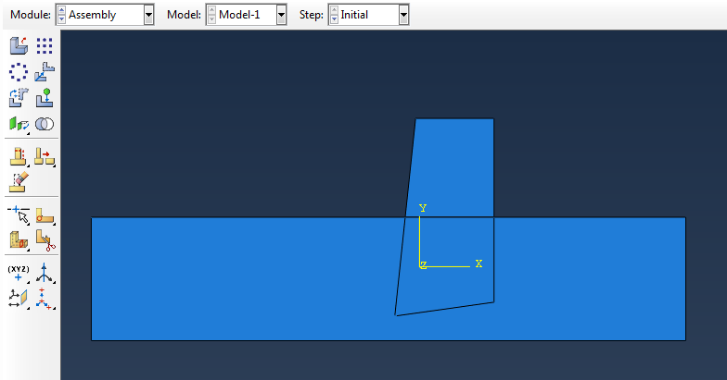
Fig. 1.11 Preliminary arrangement of elements in the assembly

To move the elements, use the “Translate Instance” option. Click this icon to display the “Select the instance to translate” message: select the element to be moved and click “Done.” Then, using appropriate points on the cutting tool and workpiece geometry and the translation by a specified vector, place the cutting tool so that the cutting edge is moved away from the workpiece top by 0.153 which is shown in Fig. 1.12.

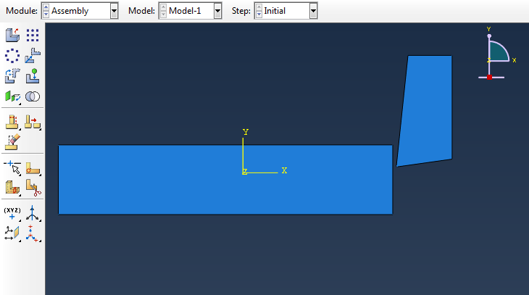
Fig. 1.12 Correct location of elements in the assembly

Define the analysis steps
The steps are created in the “Step” module in which you should select “Create Step.” Give a name in the new “Name” window and set the parameters according to Figure 1.13 and press “Continue” to accept. This will open the “Edit Step” window in which in the “Time Period” field you should enter 0.01, and use the default settings for the remaining options as shown in Fig. 1.14.

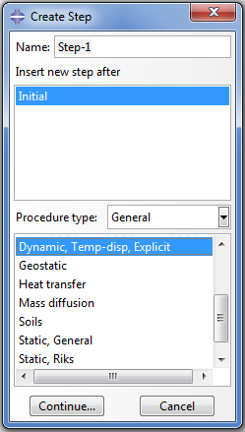  Fig. 1.13 Step definition | 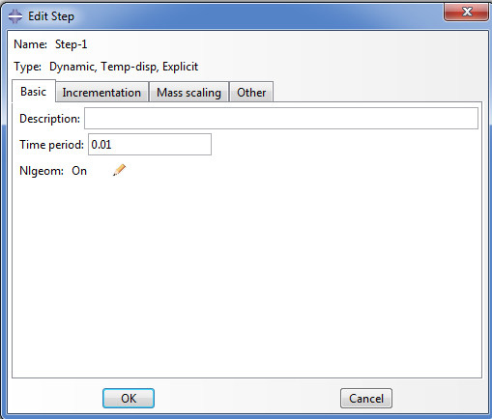  Fig. 1.14 Enter Step parameters

Determine the output data
All output data created during the analysis are directly recorded in the “Output Database.” The obtained results depend on the used parameters and features which should be indicated in “Field Output” and “History Output.” To set the parameters in “History Output”, use the “History Output Manager” tool in the “ToolBox” area. Open the “History Output Requests Manager” window, use the “Edit” button and check the options shown in Figure 1.15.

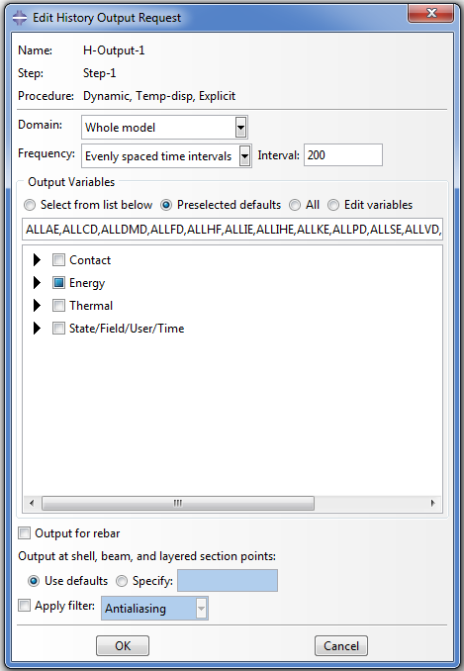
Fig. 1.15 Settings in "Edit History Output"

Perform the identical operations after selecting “Field Output Manager” according to Figure 1.16. A very important parameter to be checked in the “Edit Field Output Request” window is “STATUS” in the “State/Field/User/Time” category because it is responsible for the separation of the grid during the turning process simulation (Figure. 1.17). An incorrect setting of this function will cause a significant error in the simulation results.

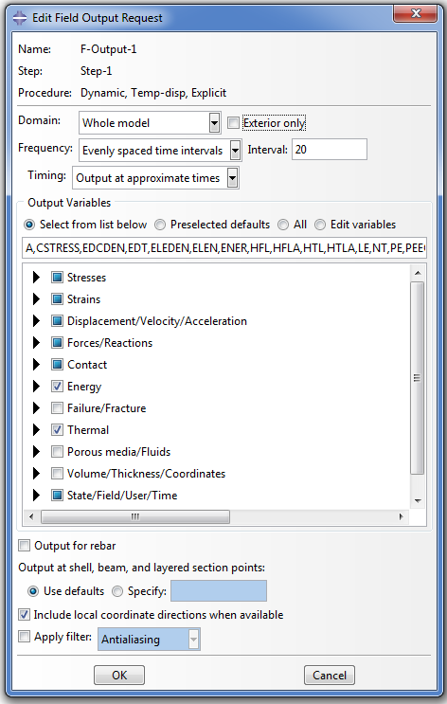  Fig. 1.16 Checked output features | 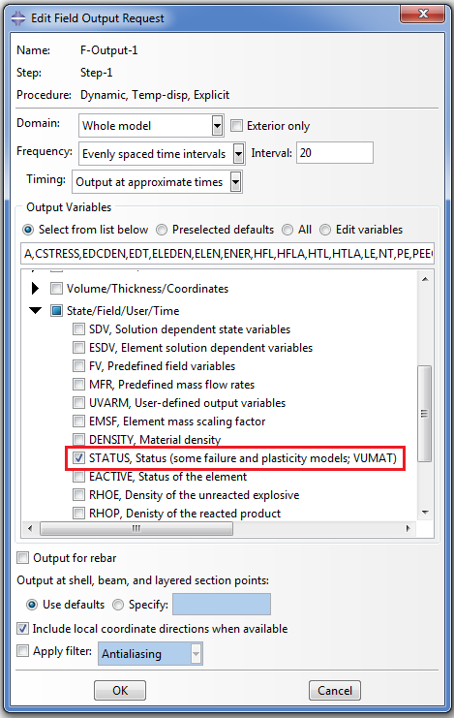  Fig. 1.17 Checking “STATUS”

